Forty-9er Assembly Instruction Manual
by Dr. Jack Purdum, W8TEE; Farrukh Zia, K2ZIA; Dennis Kidder, W6DQ

This addendum presents additional assembly instructions that we made while assembling the Forty-9er. It’s a fun little rig and you just can’t beat the price.

READ THROUGH THIS ENTIRE MANUAL BEFORE ASSEMBLING ANYTHING.

The order in which you do things can make it much easier to assemble the transceiver, or more difficult if you use a different sequence for assembling the boards.
The instructions presented here are used in conjunction with the QST article for modifying the Forty-9er. In addition to the normal kit assembly tools, we suggest you have a flash light and magnifying glass.
We have also included the modifications necessary to the Forty-9er board to make it easier to add the new LCD display and the DDS VFO. Adding the LCD display and the VFO requires some parts be left off the original Forty-9er board and additional parts added onto it. These changes are presented here, so you will know what not to solder onto the Forty-9er board from the stock parts list you received when you bought your Forty-9er kit.

SN | Parts needed for Forty-9er board modifications: | Quantity
1 | R5 replacement 10 kΩ | 1
2 | D2 replacement 5.1 V Zener diode | 1
3 | Inductor 22 µH | 1
4 | Disc ceramic capacitor 56 pF | 1
5 | Header Pins (single row 1x4) | 1

SN | Parts needed for Nano DDS VFO: | Identification / Code | Schematic & PCB  Reference | Quantity
1 | DDS VFO PCB |  | PCB | 1
2 | Header-socket-10pin |  | U3 socket | 2
3 | Header-socket-15pin |  | U2 socket | 2
4 | Header-pins-2x4-white |  | J1-A | 1
5 | Header-pins-2x4-yellow |  | J1-B | 1
6 | Header-pins-2x4-blue |  | J1-C | 1
7 | Header-pins-1x8-black |  | U1,J2,J3 | 1
8 | Volt-Reg-Mini-360 | Circuit Module | U1 | 1
9 | Transistor-2N2222A | Emitter-Base-Collector  (Front View) | Q1,Q2 | 2
10 | Diode-1N4001 |  | D1,D2,D3 | 3
11 | Inductor-100 µH | Brown-Black-Brown-Silver | L1 | 1
12 | Capacitor-100 nF-50V | Ceramic-104 | C1 thru C7 | 7
13 | Capacitor-100 µF-25V | Electrolytic-100uF-25V | C8 | 1
14 | Resistor-TrimPot-10k | Plastic-103 | R1,R8 | 2
15 | Resistor-220-1/4W | Red-Red-Brown-Gold | R2 | 1
16 | Resistor-1k5-1/4W | Brown-Green-Red-Gold | R3 | 1
17 | Resistor-12k-1/4W | Brown-Red-Orange-Gold | R4 | 1
18 | Resistor-470-1/4W | Yellow-Violet-Brown-Gold | R5a,R5b | 2
19 | Resistor-470-1/4W | Yellow-Violet-Brown-Gold | R6a,R6b | 2
20 | Resistor-20k-1/4W | Red-Black-Orange-Gold | R7 | 1
21 | Arduino Nano Module |  |  | 1
22 | AD9850 DDS Module |  |  | 1
23 | 16x2 characters LCD  with I2C interface |  |  | 1
24 | Rotary Encoder  with integrated switch |  |  | 1
25 | Dupont jumper wires (F-F), 8” length |  |  | 10
26 | RG174 coax cable, 6” length  (optional, for connecting DDS VFO output to Forty-9er and Forty-9er output to antenna BNC connector) |  |  | 2

Header pins are built from standard header pins available from www.ebay.com. Search for,
“10PCS 40Pin 2.54mm Single Row Straight Male Pin Header Strip PBC Arduino”.

The following sequence allows the board to be built and soldered in layers, starting with the lower profile components and then gradually installing components with more height.

Sequence of parts placement for soldering on the 40-9er PCB.

1. IC sockets
2. Ceramic capacitors (0.1 μF)
3. Ceramic capacitors (all others)
4. Electrolytic capacitors (1 μF and 10 μF)
5. Resistors
6. Header pins in place of Y2, Jumper across W1
7. Diodes
8. TO92 transistors and U1 (VR)
9. Electrolytic capacitors (100 μF)
10. Inductors
11. Jacks and Connectors
12. Power Transistor

Figure A1 shows the original Forty-9er schematic as received with the kit. For the most part, the modifications made apply to the crystal-controlled filter and oscillator supplied with the kit.
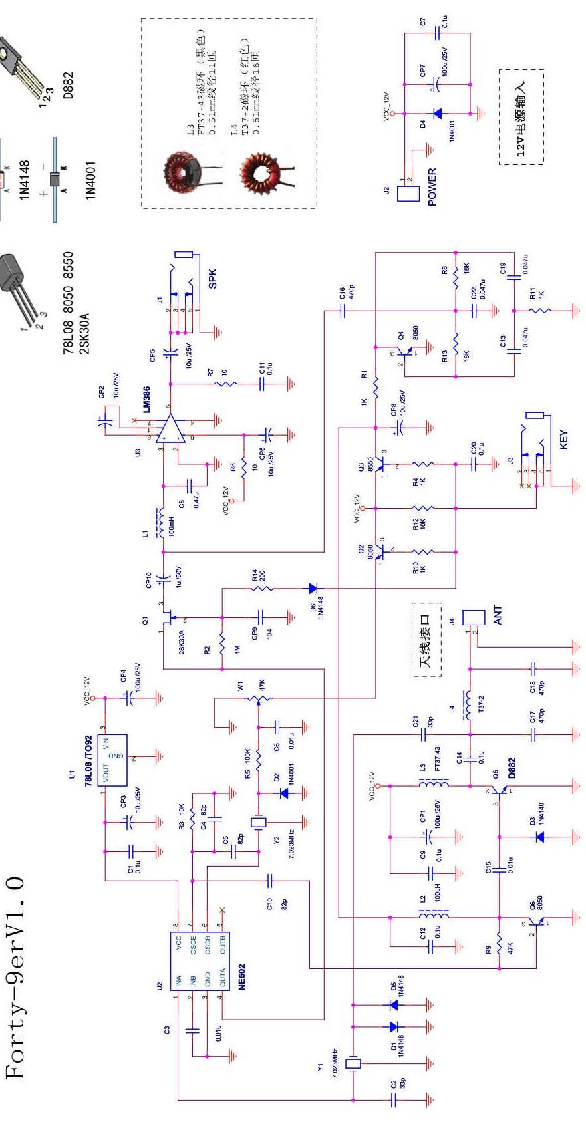
Figure – A1 Original Forty-9er Schematic.
Kit Modifications
Because a digitally controlled DDS VFO is used to provide the transmit oscillator signal while covering the entire 40 m band, the internal oscillator in the NE602 or NE612 chip and its associated components (R3, C4, C5, Y2, D2, R5, C6, W1) are no longer needed. In order to shift the transmit frequency over a small offset, the DDS VFO microcontroller needs to know when the KEY is in UP or DOWN (RX/TX) position. This signal comes from the KEY switch transistor Q2. Because the microcontroller digital input can withstand a maximum voltage of only 5.5V, a 5.1V Zener diode is used to limit the 12V dc signal from Q2 to 5.1V. You can substitute other values for the Zener diode as long as they control the voltage so it can be interpreted as logic HIGH (that is, 3.3-5.1V). The control pin on the board is routed to pin 12 on the Nano board. The full schematic of the modified board appears at the end of this Addendum.

Table A1. Parts and Placement Changes.
Component | Value | Note
R3 | 10 kΩ | Do not install
C6 | 0.01 μF | Do not install
C4, C5 | 82 pF | Do not install
R5 | 100 kΩ | Replace with 10 kΩ
W1 | 50 kΩ trimmer pot | Replace with jumper (see schematic diagram and picture)
C2 | 30pF or 33pF | Replace with 82 pF capacitor
D2 | 1N4001 | Replace with 4.7 V or 5.1 V Zener (install in same orientation as D2)
Y1 | 7.023 MHz | Replace with series LC filter (see schematic diagram and picture)
Y2 | 7.023 MHz | Replace with 3 pin header (see schematic diagram and picture)

You may find it useful to draw an “X” through the components in Table A1 that are not used. That will help to prevent you from mounting components on the board that are no longer used.

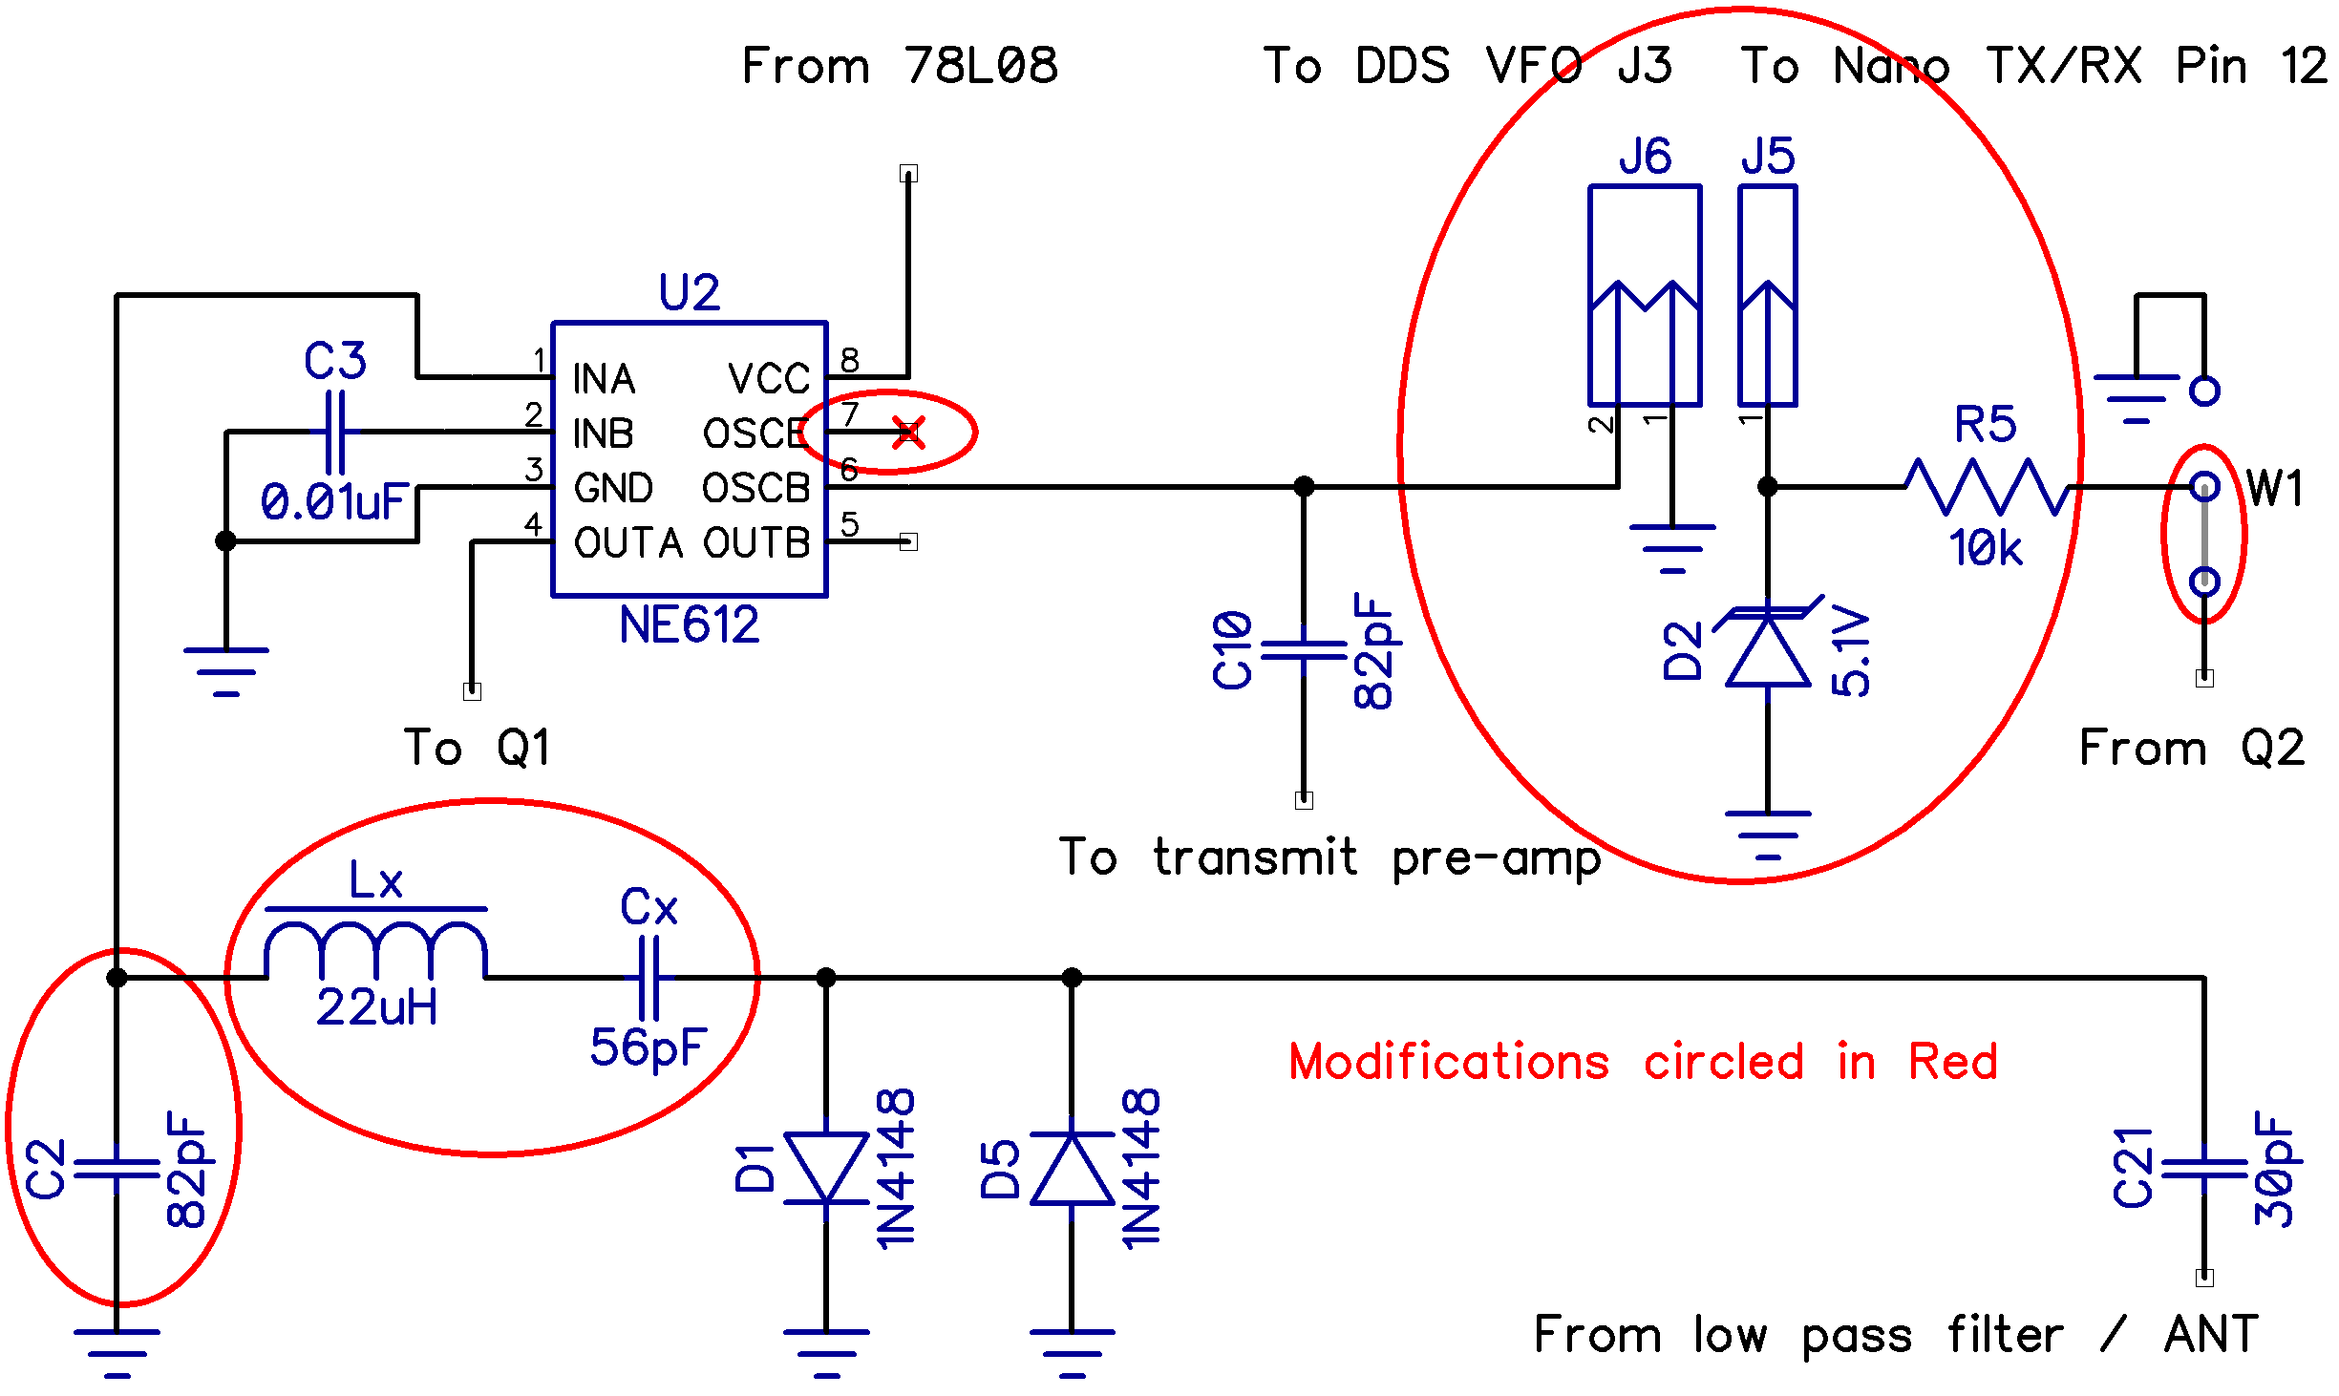

Figure A2 – The modifications for the Forty-9er board.

The modifications shown in Figure A2 involve removing the two (receive filter and transmit oscillator) crystals and modifying the circuit around the crystal locations. Also note that original schematic shows C21 and C2 values as 33pF but the actual kits contain 30 pF capacitors as shown in modification schematic. Pin J5 carries receive frequency offset signal to Nano. J6 carries the DDS VFO output to the NE602 or NE612 (for receiver demodulation) and to transmit pre-amp (via C10). Note; header pins labeled J5 and J6 and circled in red in Figure A2 are new pins we added to the Forty-9er board. (These show up as yellow pins in Figure A4.)

Receive filter modification:
In the original circuit, C21, Y1, C2 form a narrow band receive crystal filter. This is replaced with a wider band LC filter which covers the entire 40 m band from 7.000 to 7.300 MHz. We used LT-Spice simulations to model the receive filter response. Model and response are shown in Figure A3.
We used C21 (30 pF) and C2 (82 pF) for the modification because they become unused parts already included in the kit. In Figure A3 left, C15 (8 pF) in the design is the combined capacitance of limiter diodes D1 and D5 (4 pF each, from 1N4148 datasheet). Cin and Rin are input capacitance and impedance of NE602 mixer input pin 1 (from NE602 data sheet).

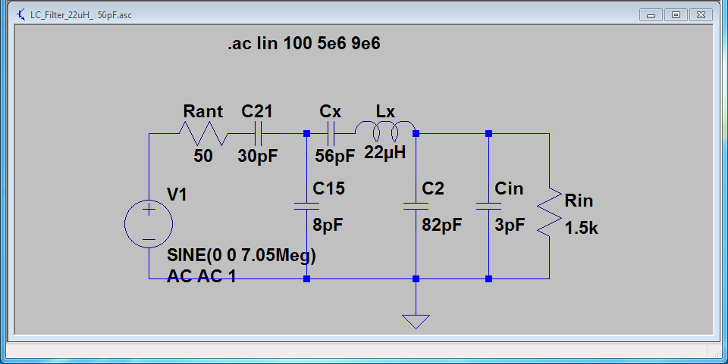
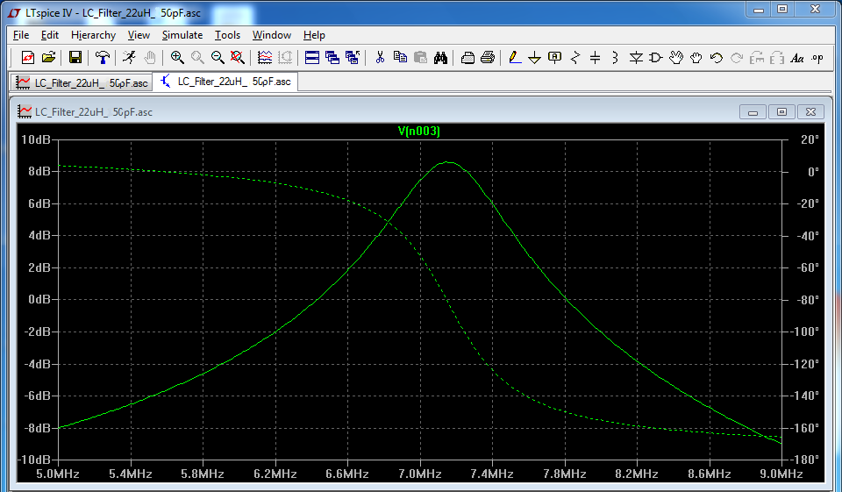
Figure A3 – Filter model (top) and response (bottom).

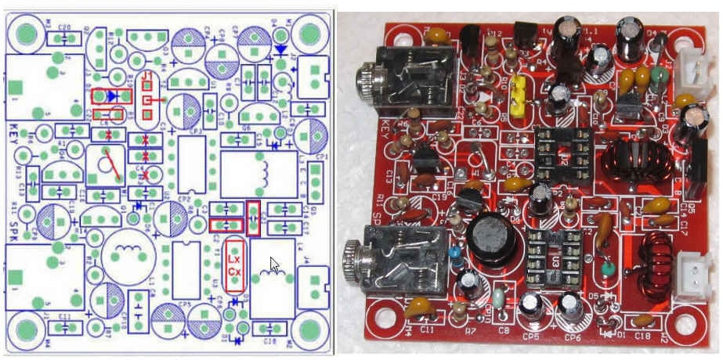
Figures – A4 Modifications made to the board.

Parts Inventory and Prep Work
You must do a parts inventory. As it turned out, all of the kits we ordered had extra parts shipped with the kits, although one kit was short on the 0.1 μF capacitor count. While more is better than having missing parts, it can be disconcerting to finish building something only to discover anywhere from 3 to 5 parts left in the parts bin.
Our preferred inventory method is to use a large chunk of Styrofoam into which we can punch the parts as we check them off the list. It’s probably a bad idea to stick static-sensitive components, like ICs and transistors, into the foam. Just leave those to the side of the Styrofoam sheet. Line up parts as you do the inventory. For example, if there are four 1 kΩ resistors on the parts list, line them up one behind the other in the Styrofoam. That way, they are easy to count during the inventory and easy to find during construction. Heathkit suggested putting the components into the “holes” left when you cut out a piece of cardboard and sit it upright on edge. Use whatever you think best.

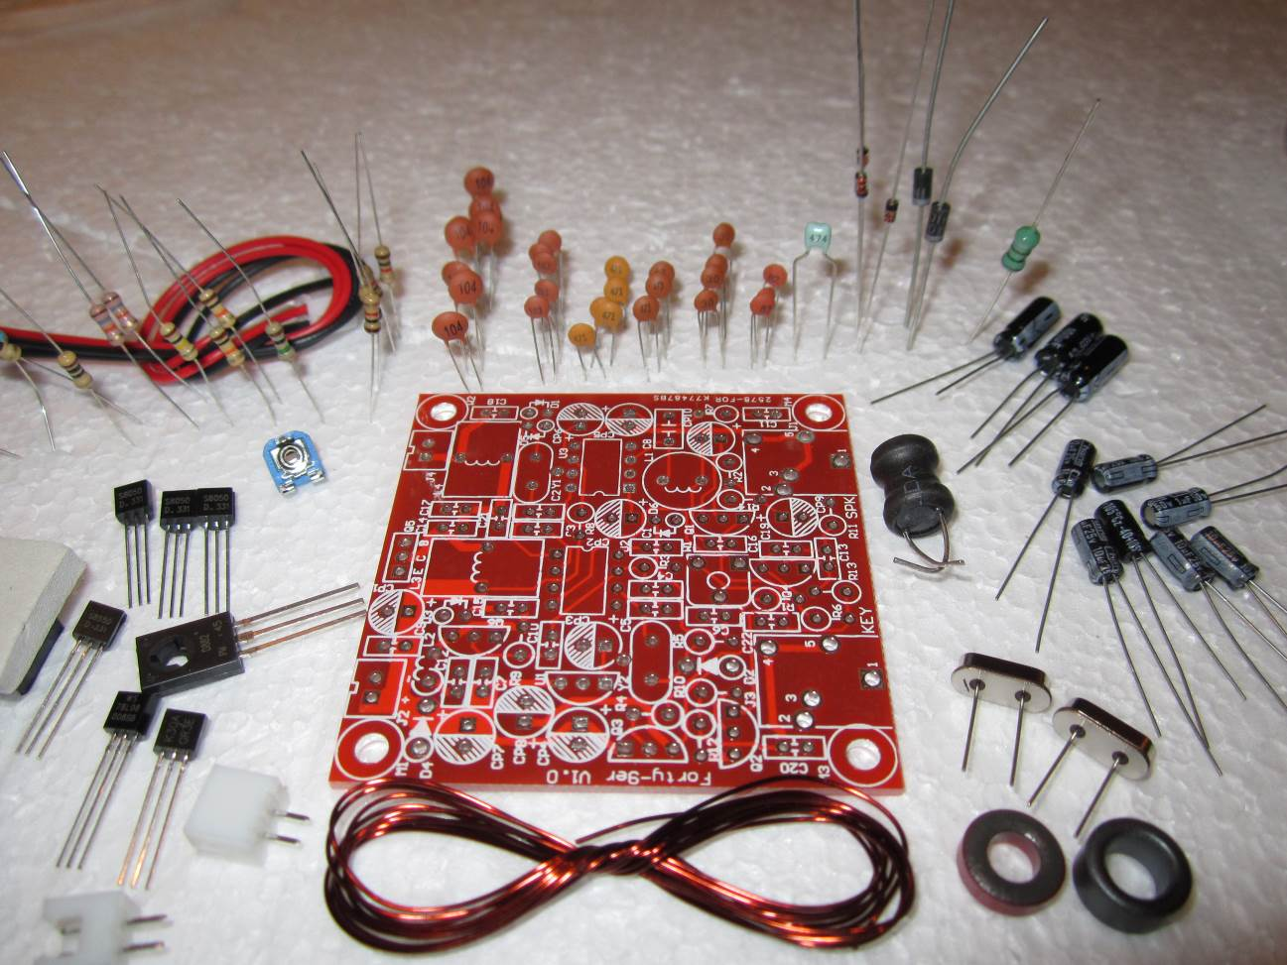
Figure A5 – Taking a Parts Inventory.

Table A2 may help you inventory the resistors by their color codes.

Table A2. Color Codes for Resistors
Parts | Resistance | Band Colors
R1, R4, R10, R11 | 1 kΩ | Brown, Black, Red
R2 | 200 kΩ - 1M kΩ | Red, Black, Yellow to Brown, Black, Green bias resistor
R3, R12 | 10 kΩ | Brown, Black, Orange
R5 | 100 kΩ | Brown, Black, Yellow – Replace  with 10 kΩ, Brown, Black, Orange
R6, R13 | 18 kΩ | Brown, Gray, Orange
R7,R8 | 10 Ω | Brown, Black, Black
R9 | 47 kΩ | Yellow, Violet, Orange
R14 | 200 | Red, Black, Brown

The capacitors are pretty clearly marked, but you may need to use the magnifying glass, and perhaps a flashlight, to read the numbers on them. The relationship between the number on a cap and its value, see the EIA Capacitor Values or go search www.elecraft.com/Apps/caps.htm for some sample capacitance values relative to their numbers.
The electrolytic capacitors are easily identified, just pay attention to their polarity when you install them. Most have a thick white band on the casing with a minus sign on it to identify the negative lead. The silk screen has a “shaded half circle” painted on the negative lead. On our boards, C19 is silk screen on the board as an electrolytic, but is actually a disc cap now. (It's correct on the parts list.)
Diodes and Zener diodes have a band around their cathode (negative) lead. The only other part that might be confusing are the inductors. They look like a fat resistors, but have a greenish base color versus the tan or blue base color for resistors. (You can see the inductor sticking upright in the upper-right corner of Figure A5.)

Toroid Winding
You must wind inductor toroids L3 and L4 yourself according to Table A3. It’s easy.

Table A3. Inductor windings
Part | Turns | Core
L3 | 11 | FT37-43 (Black core)
L4 | 16 | T37-2 (Red core)

To make each toroid, first cut the supplied enamel wire approximately in half. Holding about 1 inch extra from the end, push the other end over the top of the core, then back through the middle and then back to the top of the core. That loop counts as one turn. Keep repeating until you have completed the required number of turns according to Table A3. After you’re done, fan the turns so they are more-or-less evenly distributed around the core. Take a sharp tool (or light sandpaper) and carefully scrape away the enamel from both leads up to the bottom of the core. Alternatively you can use the tip of a hot soldering iron to melt the enamel away, which removes the risk of nicking the wire. Either way helps make a good solder joint with the PCB. We always perform a continuity test with a DMM after we’ve soldered them in place just to make sure we have a good connection.
Do not mount the toroids on the board yet.

Pre-Assembly Considerations
You can put the parts on the PCB any way you wish, but we always follow a pattern when assembling a kit with “skimpy” instructions. First, there are quite a few parts to fit on the small area of the Forty-9er PBC. It’s a pretty dense board, especially for fat-fingered old people. Also, there is no apparent organization to the positioning of the parts. That is, R1 might be at the northwest corner of the board while R2 is at the southeast corner. The printed instructions have a copy of the board’s silk screen and we found that invaluable in locating where a part was to be placed. You might find it helpful to use a yellow highlighter pen to color each component on the schematic as it is added. That makes it easier to find the location of the remaining components.
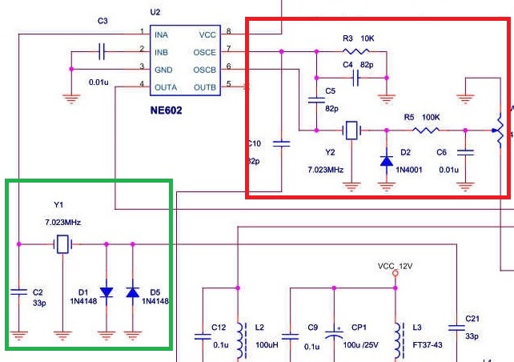
Figure A6. The Original Forty-9er Circuit from Vendor.

Figure A6 shows the original circuit as it comes from the seller, as compared to the modifications shown in Figure A2. Because we are adding an LCD display and DDS VFO to the rig, the original circuit needs several modifications. Most of the modifications are focused on the NE602 double-balanced mixer U2 in Figure A6. Both crystals Y1 and Y2 are removed from the circuit to convert the circuit from a crystal-controller to oscillator to a VFO.

Figure A7. Schematic of Modifications to Forty-9er board, shown earlier as Figure A2.

Before You Solder Anything on the Forty-9er Board...
We learned the hard way that assembly is easier if you follow a specific sequence. We are repeating Figure A2 here as Figure A7 to make it easier to reference the schematic during the discussion.
Replace the input crystal receive filter (Y1) of Figure A6 with an LC tuned circuit shown in Figure A7 consisting of a 22 μH inductor (Lx) and a 56 pF capacitor (Cx). Place this filter near diodes D1-D5 on the board, in the lower-right corner of the PCB. (You can see this clearly in Figure A9.) The new oscillator circuit is placed near the location of Y2 on the circuit board. Details for adding the new components is given below.
We used (yellow) header pins to make the board connections, since this makes it easy to use Dupont jumper wires for connections between the Forty-9er and Nano/VFO boards. If you don’t have any header pins, you could make your own pins using #20 or #22 AWG wire instead. As a last resort, you could solder wires directly between the two boards, but this makes it harder to work with the two boards during construction, so we don’t recommend direct wiring.

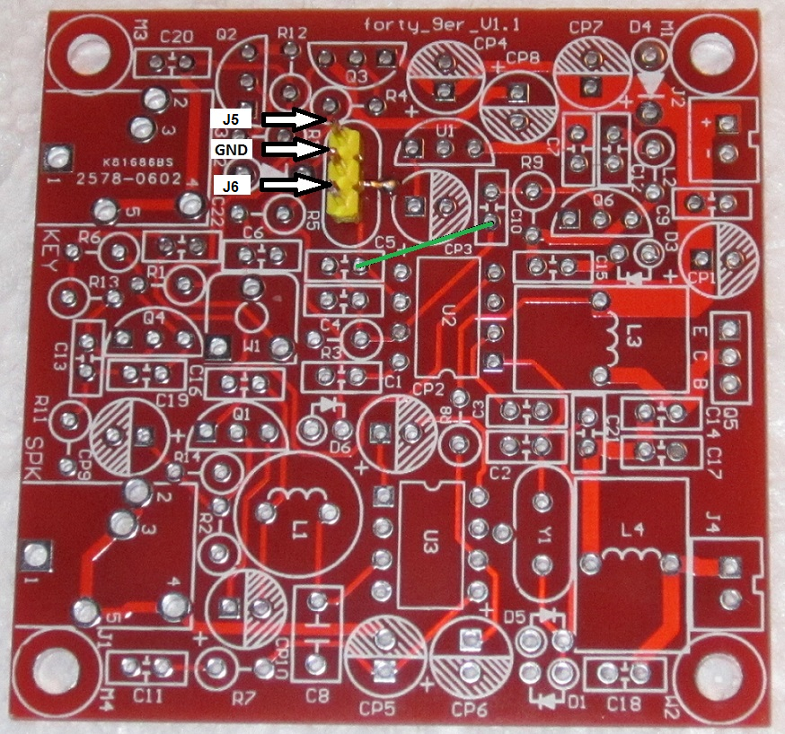
Figure A8. Soldering the middle pin of the 3 pin header at location Y2.
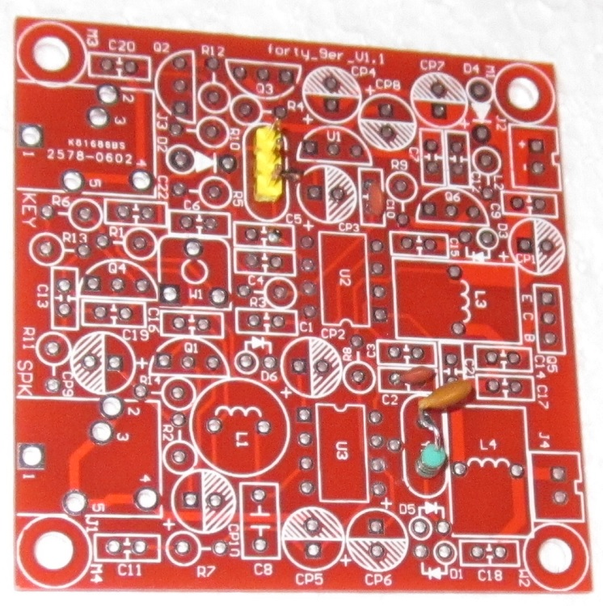
Figure A9. The narrow pass receiver filter components in place.

Forty-9er Board Modifications
We suggest this sequence of steps:
Take one of the 8 pin IC sockets and, using a pair of needle nose pliers, push on pin 7 from the bottom upwards until it pops out the top of the socket. As you can see from Figure A7, we don't use pin 7 of the NE602, but we are going to use some PCB connections that were tied to pin 7 for other purposes. Popping out the pin 7 contact assures us that we don’t use that pin of the NE602.
Cut a group of 3 pins from a row of standard header pins and, using either a snipping tool or toenail clippers. The “short end” of the pins fit into the Forty-9er board, while the “long end” of the pins will eventually be used to connect Dupont wires to the Nano/VFO board. Bend the middle short pin of the three-pin header to form a right angle. Place the three-pin header into the two holes that are marked Y2 on the board with the bent middle pin pointing towards CP3. The bent pin should almost cover a hole that’s between CP3 and the three-pin header. This middle pin is the ground connection for the J2 and J1 connections seen in Figure A7. Solder the middle pin to the hole that is between CP3 and U1. Flip the board over and solder the remaining two pins to the board. See Figure A8 for the details.
In Figure A8, you can see the silk screen for C10 to the right of CP3. You can also see the trace running from C10 to pin 7 of the NE602 chip U2 in Figure A7. We no longer use the oscillator components of the original circuit or pin 7 of U2. You can also see that the other lead of C10 connects to the base of Q6, which is the transmit pre-amp. According to Table A1 we no longer need C4 or C5 in the circuit, so with a little care, we can use their mounting holes in our modified circuit.
In Figure A8, note how the trace from our new J2 header pin passes to the right side of C5 and then to pin 6 of U2. If we don’t trim the lead from C10 but instead route it on the under-side of the PCB and through the right-side hole of C5, we complete the circuit between J2, U2, and C10 as shown in Figure A7. Because we removed the pin 7 contact in Step 1 and R3 and C4 are no longer in the circuit, the existing trace from C10 to pin 7 no longer matters.
Mount C10 on the circuit board and solder it in place, but do not trim the lead that goes to the trace that currently runs to pin 7 of U2. Instead, slip some insulation on the lead and route it to the mounting hole on the right side of C5 when viewed as shown in Figure A6. The path of the lead from C10 to the right side mounting hole of C5 is shown as a green line in Figure A8, but is on the under-side of the PCB. The 82 pF capacitor we received for C10 has pretty short leads and barely spans the distance to the C5 mounting hole. If this is a problem for you, push a bare wire through the correct C5 mounting hole and solder the wire in place. Trim off the excess from the top of the board. Now flip the board over and connect the bare wire to the lead coming from C10 and solder, thus completing the green line connection between C5 and C10. Cover the leads with electrician’s tape or use heat-shrink tubing before connecting the two leads, and shrink it after soldering. We were able to slip some Teflon tubing over the C10 lead and bend it to touch the C5 mounting hole and solder it in place.
Next, replace the narrow band receive filter that uses crystal Y1 with an LC filter built from Cx and Lx in Figure A7. We change the value of capacitor C2 from 33 pF to 82 pF. This is not a problem since we no longer need C4 or C5, both of which are 82 pF. Place one end of inductor Lx, 22 μH, into the mounting hole for Y1 and soldered it in place. Twist the other end of Lx together with one lead from capacitor Cx, 56 pF, and solder the two leads together. Mount the free end of Cx into the remaining unused hole of Y1 and solder it in place. Figure A9 shows the LC filter soldered in place.
Mounted C2 (Figure A9) making sure to replace the original value of 33 pF with the new value of 82 pF.
Replace D2 with a 5.1 V Zener diode and solder it in place. We used a 1N4733A, which is a 1 A diode. We found them locally at 10 for $1.25 at, www.debcoelectronics.com. Search for “1N4733”. Make sure you orient the diode so the cathode band mounts in the hole closest to the J2 header pins. Save one of the trimmed diode leads for step #8. D2 ensures that the voltage on the J1 header pin doesn’t exceed 5.1 V even though there is 12 V on the emitter of Q2. By reading the emitter of Q2, J1 supplies a signal to pin D12 on the Nano to sense when the transmitter is keyed.
Replace the original R5 (100 kΩ) with a 10 kΩ resistor and solder it in place. As you can see in Table A1, R3 is a 10 kΩ which is no longer needed, so you can use it for R5.
Use the trimmed lead from step #7 to make a jumper that spans W1 from its wiper to the emitter of Q2. The modifications for steps 6-8 are shown in Figure A10.
This completes the modifications that you need to make to the Forty-9er board. It wouldn't hurt to examine your work and make continuity checks with an ohmmeter to make sure you have things wired correctly.

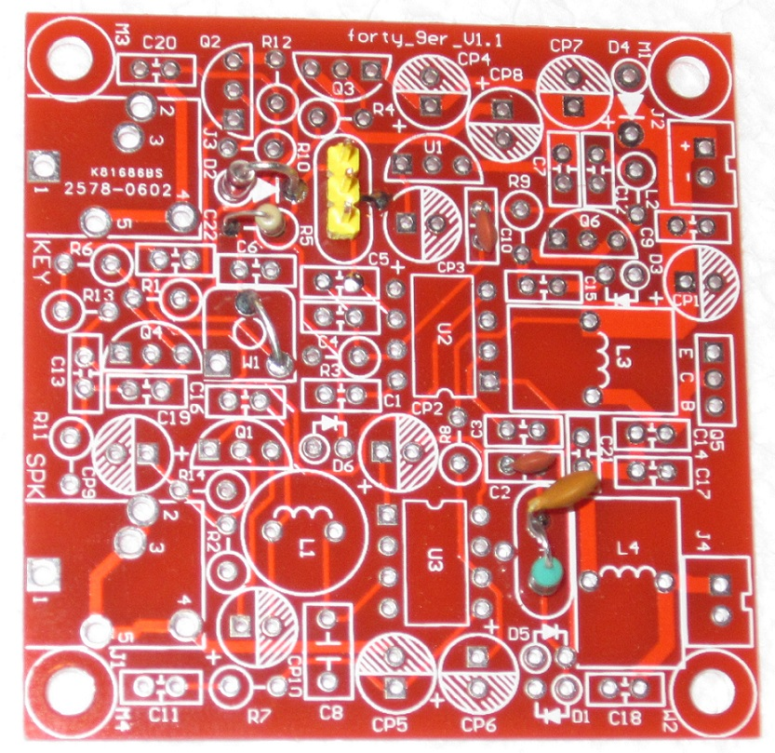
Figure A10. Oscillator modifications.

Forty-9er Component Completion
At this point, you can place the remaining components on the Forty-9er board. Make sure you follow the omission/modification details presented in Table A1, as there are components in the kit that are no longer needed.
The sequence from this point is up to you. However, we find it easiest to mount the IC sockets first. Since we want the IC sockets to sit flat on the board, we Scotch tape them to the board and then flip the board and solder them in place. Next, we place the remaining diodes on the board. Since these are heat sensitive, so solder only one lead on each diode at a time and move to the next one. After you’ve soldered one lead of each diode, go back and solder the remaining free lead. This gives the diode a chance to cool down before you solder the second lead is soldered. We do the same thing for each transistor lead, soldering one lead, move to the next, and so on, then returning to solder the second lead of the first transistor. Again, this gives the transistor a chance to cool a bit before soldering the next lead.
Next, we place and solder all of the resistors, then the (non-electrolytic) capacitors, followed by the electrolytic capacitors. Solder the large components (toroids, speaker/key connectors) last.
If you think you may add software for an electronic keyer, the Forty-9er board does NOT wire the key connector for keyer use. It assumes a straight key. You will need to route a wire from the key connector’s ring pin and tie it to an unused pin on the Nano that you want to use for the keyer. Arduino Projects for Amateur Radio has details for such a keyer, or just search with your browser for “Arduino Morse Code keyer”.

Cold Solder Joints
A cold solder joint (CSJ) is the bane of kit builders. A CSJ is a soldered connection that does not make a good electrical contact between two or more components. Often you can spot a CSJ by looking at the connection with a magnifying glass. The joint will look “grainy”, with a crystalline appearance rather than a smooth shiny surface. Sometimes you can see that the solder has not flowed evenly around a lead, causing a CSJ. We always “strum” a component lead before we trim it off. If the connection is good, the lead will give an almost musical note when you strum it with your fingernail. If you hear a thud instead of a note, re-solder the connection.

The Nano DDS VFO Board
Figure A11 shows the schematic for the VFO/Nano board. Near the upper-left of Figure A11 is a large, 24 pin header labeled J1 that provides the power and control logic for the board. This 24 pin header is nothing more than two 12 pin header blocks mounted next to each other, similar to the header built using the “yellow” pins of J5 and J6. Vin is 12 to 13.8 V at 1 A supplied from an external power supply. L1 and C4 decouple the buffer Q1-Q2 from the 12V power supply. R6 is probably sufficient to provide decoupling with C4, but L1 provides an extra measure of providing a high impedance source at RF.

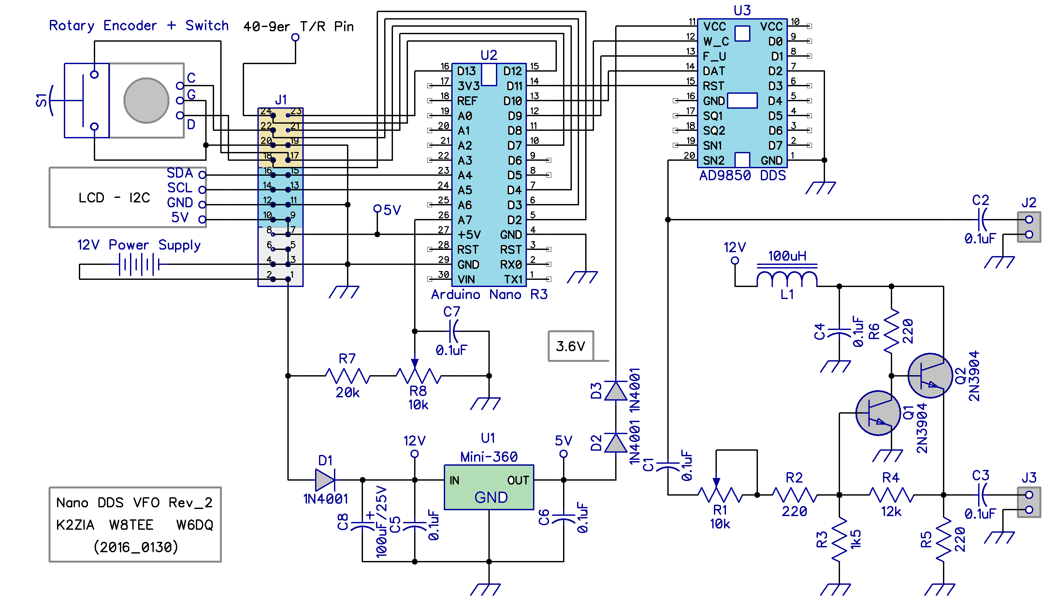
Figure A11. The Nano/VFO Schematic.

C1-C7 — capacitor, 0.1 µF
C8 — electrolytic capacitor, 100 µF 25 V
D1,D2,D3 — diode,1N4001
J1 — 24 pin header*
J2 — 2 pin header*
J3 — 2 pin header*
L1 — Inductor, 100 µH (www.vetco.net)
Q1,Q2 — NPN transistor, 2N3904 or 2N2222A
R1,R8 — trimmer potentiometer, 10 kΩ
R2 — resistor, 220 Ω
R3 — resistor, 1.5 kΩ
R4 — resistor, 12 kΩ
R5,R6 — resistor, 220 Ω, 1/2W
R7 — resistor, 20 kΩ
U1 — Mini-360 Adjustable Buck Regulator (www.ebay.com)
U2 — Arduino Nano R3
U3 — Direct Digital Synthesizer, AD9850.
S1 – Rotary encoder with integrated push switch (www.ebay.com)
LCD – 16x2 character LCD with I2C interface (www.ebay.com)

All resistors are 1/4W unless otherwise noted.
*Header pins J1, J2 and J3 are built from standard header pin strips available from www.ebay.com. Search for, “10PCS 40Pin 2.54mm Single Row Straight Male Pin Header Strip PBC Ardunio”.

Note that we refer to header pin connectors J1, J2, and J3 in this section of the manual. Keep in mind that we are now building the Nano/VFO board (see Figure A12), which is different from the Forty-9er board which has it's own set of connectors J1-J4. Pretty much anyone who can fog a mirror won't confuse the two, but we thought we'd mention it just to make sure.
The Nano/VFO board may be viewed as a “stand alone” VFO for rigs other than the Forty-9er. Many modern QRP rigs require a rather modest peak-to-peak voltage from the VFO. For example, we used a VFO with a similar design for the MFJ Cub and CRK lines of transceivers. While the filter network would need some modifications for other bands, the VFO is capable of 160 – 10 m operation. The output at J2 in Figure A11 can be used for rigs that don’t need a large peak-to-peak voltage. Some older rigs, including the Forty-9er, need a larger signal to bring the rig to its full output power. J3 provides up to 4V peak-to-peak via a small buffer amplifier on the board. You can adjust the output voltage with R1. The output from J3 in Figure A11 becomes the input to J6 in Figure A7.
Note that pin 24 on the J1 header in Figure A11 is tied to J5 in Figure A7. That is, the keyed control signal from Q2 via the 5.1 V Zener diode on the Forty-9er board becomes the control signal fed to pin D12 on the Nano/VFO board. This signal is used by the VFO control software.
The I2C bus is used to route display output to the 2x16 LCD display. The I2C bus simplifies the display connections because only 4 wires are required (SDA, SCL, GND, and 5V). These I/O pins are pins 16, 14, 12, and 10 respectively on the J1 header. Dupont wires connect from those pins to the appropriate pins on the LCD display.
Pin 17 (D4) on J1 is tied to the encoder’s center switch pin, while the rotary encoder clock and data pins are tied to pins 18 (D2) and 22 (D3) on J1. For the Nano, D2 and D3 are the pins used for external interrupts. The interrupts fire whenever the user rotates the encoder shaft. Interpreting the pulse train from the encoder allows the software to determine whether the user is tuning up or down the band.
Resistors R7 and R8 on the Nano/VFO board form a voltage divider circuit across the 12V power supply input. The output of this voltage divider is fed into analog input A7 of the Nano. This arrangement will be used in a future revision of the control program to measure and display the power supply voltage especially when the rig is powered by a 12V battery for portable operation.

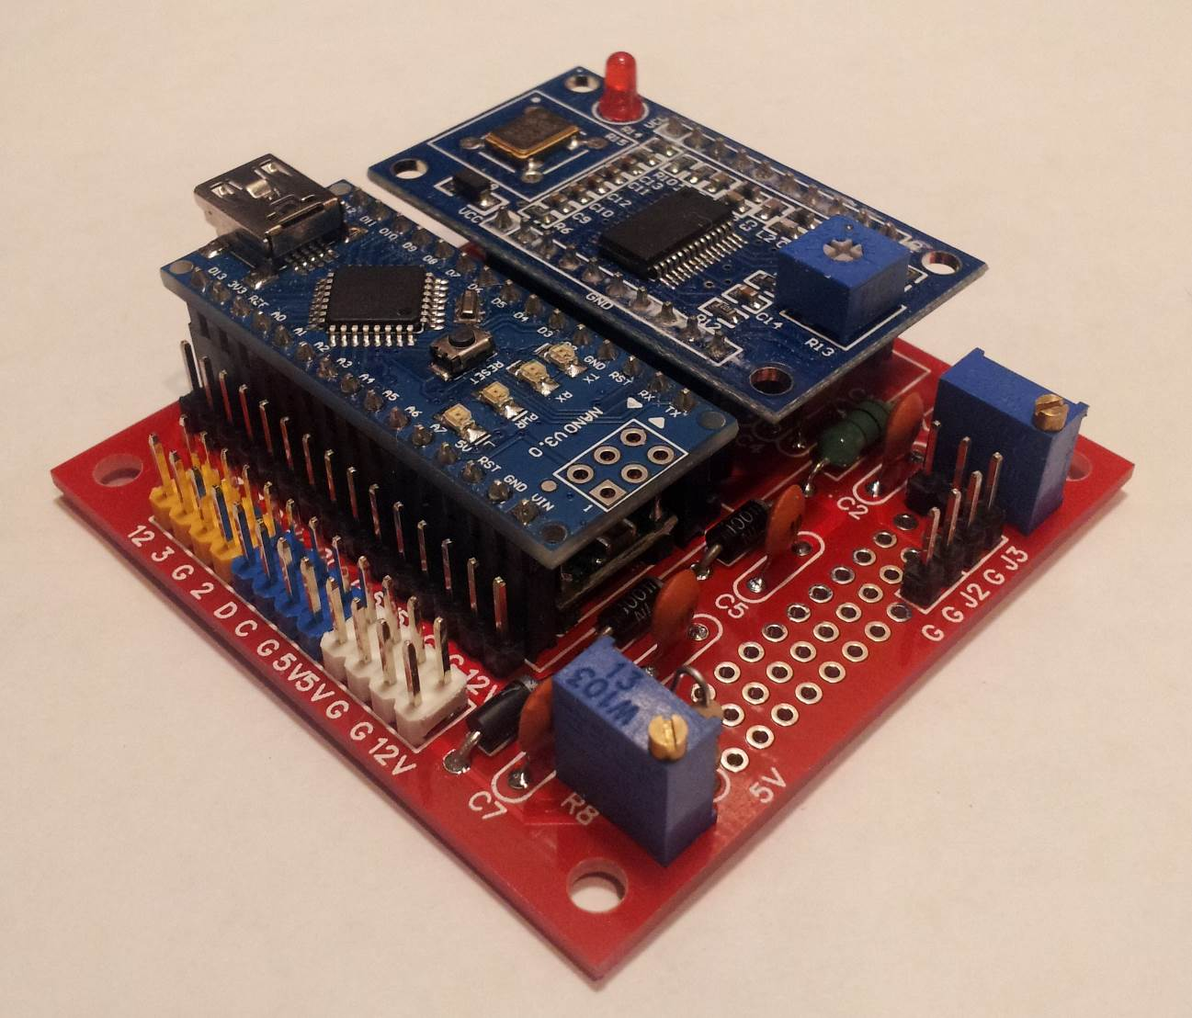
Figure A12. Nano/VFO PCB.

Figure A12 shows the Nano/VFO PCB. Most of the discrete components mount flush to the PCB and are located under the Nano/VFO boards. Note the 24-pin header on the lower left of Figure A12, and the output header towards the right corner. For the output header, the right-most two pins in Figure A12 form J3 in Figure A11 and the left-most two pins are J2. Use J3 with the Forty-9er. The unpopulated as well as populated board can be seen in Figure A13.

After the Nano DDS VFO board is fully populated but BEFORE the Nano and DDS modules are plugged into their socket headers, the output of the Mini-360 adjustable buck regulator must be adjusted to 5.0V. For this adjustment, connect 12V power to J1 pins 2 and 4, connect DMM probes to the 5V and G (Ground) pads on the side of Nano/VFO PCB (see Figure A12) and slowly rotate the tiny round trimmer potentiometer on the Mini-360 module with an insulated jeweler’s Philips screw driver until you measure exactly 5.0 V on the DMM.

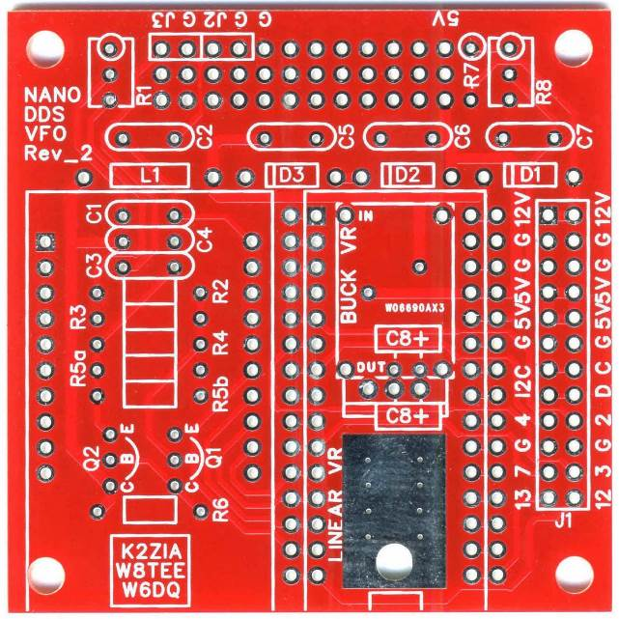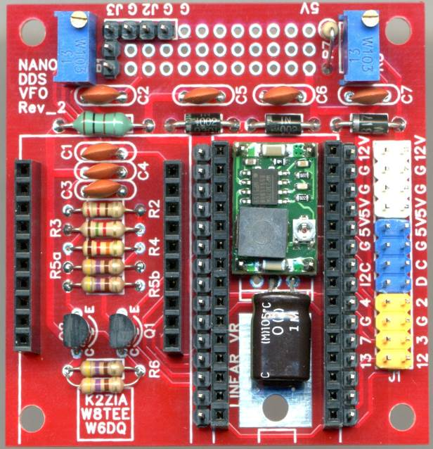
Figure A13. An unpopulated Nano/VFO PCB next to a populated PCB.

12V power for the Forty-9er is taken from pins 1 and 3 of the J1 header on the Nano/VFO board. Most of the parts seen on the silkscreen are mounted under the Nano and AD9850 boards as seen in Figures A12 and A13. At the last minute, we did add an On/Off switch between the external power supply and the header, although this is not shown in the schematics.
Figure A14 shows the populated Forty-9er board (before mounting the IC's). Note the missing “tooth” for pin 7 on the socket for the NE602/612 chip, U2. When you mount the boards in the case of your choice, just “snug” the mounting bolts, as over-tightening could crack the PCB.

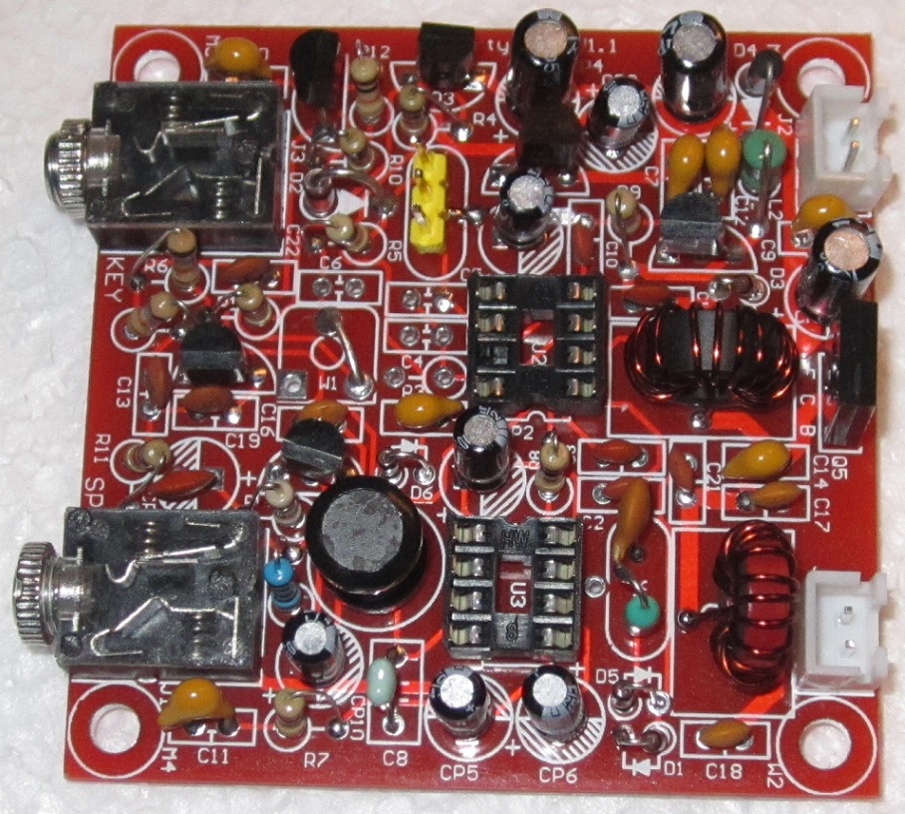
Figure A14. The Populated Forty-9er Board, less the ICs.

Testing
There’s really not much you need to test. The first thing, with a magnifying glass, scan the board for solder bridges or perhaps a piece of a wire that may have stuck to the board. Next, perform a continuity test on the positive lead of the power connectors to ground for both boards. If this shows no resistance, start looking for a solder bridge or some other form of short.
If everything looks normal, plug in a pair of headphones into the speaker jack, connect a 40 m antenna to J4, and apply power to J1 on the Nano/VFO board. After the sign on splash screen, you should hear “white noise” in the headphones. If not, recheck your connections. If you do hear the white noise but no CW signals, turn the VFO knob again. You should hear the frequency shift and perhaps hear a CW signal. If not, recheck your wiring.
If everything is going well, connect a key into the key input jack. If you can, turn on another rig and tune to the displayed Forty-9er frequency, and press the key. You should hear a note coming from your earphones (the sidetone from the Forty-9er) as well as from the second receiver. You may have to tune up or down a few kilohertz to find your signal. Note the frequency and adjust your VFO offset via software as described in the article.

Done!
You are now done, except for finding an enclosure for the rig. While a metal enclosure would be best, we used a plastic acrylic enclosure from www.usacrylic.com.
We hope you found these additional instructions helpful.

PC Board Availability
We have a limited number of PCBs for the Nano/VFO board, which makes things a little easier to assemble. Please visit www.farrukhzia.com/k2zia or email Farrukh at k2zia@arrl.net before ordering a board to make sure we still have one available at a cost of $6.95. The board is approximately 2 inch by 2 inch and is red to match the Forty-9er board (Figure A13). If you would like to purchase a board, send a check or money order to,

Farrukh Zia (K2ZIA)
799 Carpenter Rd
North Brunswick, NJ 08902, USA

